# Technical Architecture:

Project Design Phase – II Technology Stack (Architecture & Stack)

|  |  |
| --- | --- |
| **Date** | 17 November 2022 |
| **Team ID** | PNT2022TMID43833 |
| **Project Name** | Project - Classification of Arrhythmia by Using Deep Learning with 2-D ECG Spectral Image  Representation |
| **Maximum Marks** | 4 Marks |

The Deliverable shall include the architectural diagram as below and the information as per the table1 & table 2

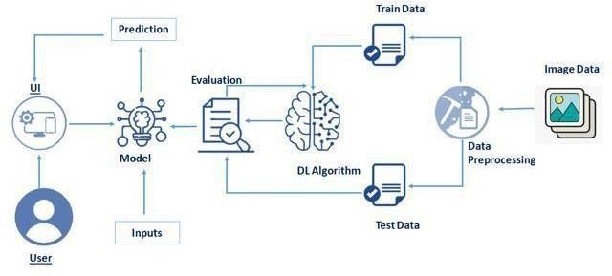

# Table-1 : Components & Technologies:

|  |  |  |  |
| --- | --- | --- | --- |
| **S.No** | **Component** | **Description** | **Technology** |
| 1. | User Interface | How user interacts with User interface to upload image | Anaconda, jupyter, spyder, python. ext |
| 2. | Model analyses | Once model analyses the uploaded image, the prediction is showcased on the UI | Kaggle.com, data. gov, UCI |
| 3. | Data collection | Create the dataset | Python, keras, numpy |
| 4. | Data Preprocessing-1 | Import the ImageDataGenerator library | Python, keras, numpy |
| 5. | Data Preprocessing-2 | Configure ImageDataGenerator class | Python, numpy, keras |
| 6. | Data Preprocessing-3 | Apply ImageDataGenerator functionality to Trainset  and Testset | Python, numpy, keras |
| 7. | Model Building-1 | Import the model building libraries and Initializing The model | Python, numpy, keras |

**Table-2: Application Characteristics:**

|  |  |  |  |
| --- | --- | --- | --- |
| **S.No** | **Characteristics** | **Description** | **Technology** |
| 1. | Open-Source Frameworks | Open source software is that by which the source code or the base code is usually available for modification or enhancement. | Flask(python) |
| 2. | Security Implementations | By placing a filtration barrier between the targeted server and the attacker, the WAF is able to protect  against attacks like cross site forgery, cross site scripting and SQL injection. | e.g. SHA-256, Encryptions, IAM Controls, OWASP etc. |
| 3. | Scalable Architecture | Does not affect the performance even though used  by many users. | Technology used |
| 4. | Availability | Justify the availability of application (e.g. use of load balancers, distributed servers etc.) | Technology used |
| 5. | Performance | Design consideration for the performance of the application (number of requests per sec, use of Cache, use of CDN’s) etc. | Technology used |